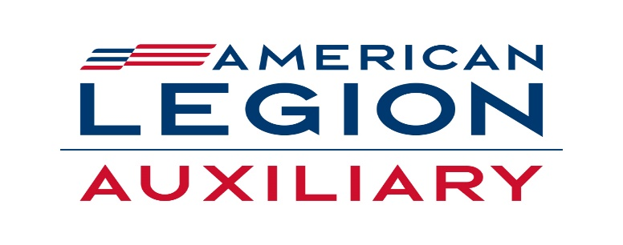

American Legion Auxiliary Maureen Morgan
Department of New York, Inc. Department President
1580 Columbia Turnpike, Bldg. 1, Suite 3 Barbara A. Corker
Castleton-On-Hudson, NY 12033 Secretary/Director of Operations
(518)463-1162

2025-2026 Plan of Action Order Form

$25.00 each
Please make check out to ALA Department of NY and mail to:
ALA, Department of New York
1580 Columbia Turnpike, Bldg. #1, Suite #3
Castleton-on-Hudson, NY 12033

Name of ALA Member________________________________
Mailing Address_____________________________________
City_______________________State_________Zip________
Number of POA’s_______________

All POA’s will be mailed out Priority mail.

